Mental Health Resources

Pathways to Empower: Mental Health Literacy programs for all audiences. Here is a QR code to go directly to a discounted parent program:
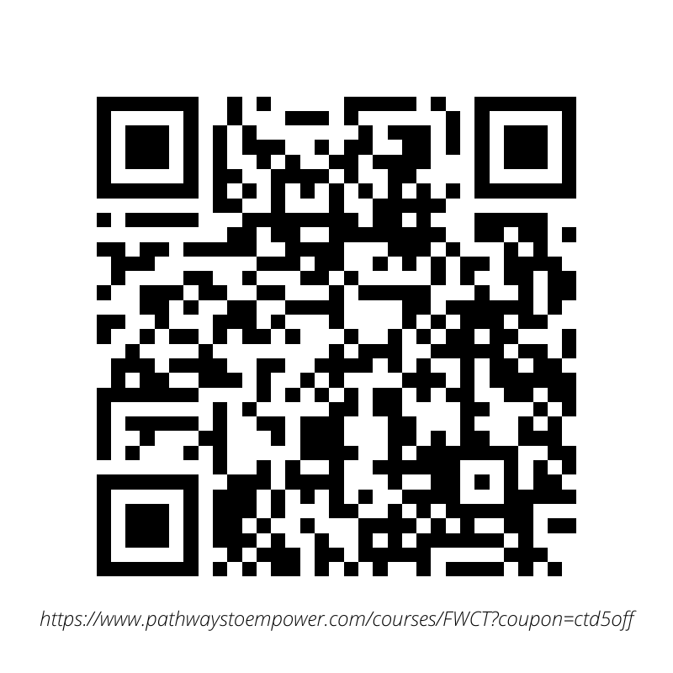
Connected Mind: Free mental health screening tool (www.connectedmind.me)

Psychology Today: Offers a directory of therapists that is searchable by location and specialty

Zocdoc: Offers a directory of therapists that is searchable by location, specialty, and insurance

Telehealth services: Offer monthly rates for therapeutic services.
betterhelp.com
goodtherapy.org
talkspace.com

Comprehensive Mental Wellness Platform:
Mindfulness for a Messy Life:

Whether you're contending with anxiety or depression, or are simply overwhelmed by the ongoing stressors of everyday life, managing life's 'mess' can become a full-time job–an exhausting, dispiriting one at that! Combining the best of positive psychology, mindfulness practices, somatic awareness, and cognitive behavioral therapy, Mindfulness for a Messy Life will help you get back in touch with the healthy, vibrant person you are underneath all that mess. Through the MfML programs, tools & resources, you will learn to relate to yourself from a place of understanding and acceptance; recognize yourself as valuable, and worthy of love and respect; build an inner foundation of compassion, and develop the kind of grounded optimism that fosters meaningful change.

Child & Teen Specific: Some organizations that specifically offer services for children and teens.

teencounseling.com
talkspace.com
littleotterhealth.com
Youth Mental Health Project: https://ymhproject.org/ The Youth Mental Health Project is a nonprofit organization whose mission is to educate, empower, and support families and communities to better understand and care for the mental health of our youth. We envision a world made up of informed families and caring communities that realize and strengthen the mental health of our youth -- a world where people are just as aware of their mental health as their physical health, where families are validated and able to readily access the care they need.
Wilderness Therapy and Residential Treatment Search Facebook Group: https://www.facebook.com/groups/wtrswildernessresidentialsearch
Seeking Help in a Crisis

The earlier we seek help, the better. But sometimes, there will be crises where we need to seek help immediately.

Launched in July 2022, the 988 Suicide and Crisis Lifeline provides 24/7 free and confidential support to people in suicidal crises or emotional distress.

National Suicide Prevention Lifeline 800-273-8255

Find a Helpline: https://findahelpline.com

Self-Medication Abuse/Addiction Resources: https://www.drugabuse.gov/

The National Institute of Mental Health: https://www.nimh.nih.gov/index.shtml

SAMHSA 1-800-662-HELP (4357)- free, confidential, 24/7, 365-day-a-year treatment referral and information service (in English and Spanish)

National information and Mental Health support: https://www.nami.org/#

Mental Health.gov
https://www.mentalhealth.gov/get-help/immediate-help

211.org https://www.211.org/get-help/mental-health

Mentalhelp.net https://www.mentalhelp.net/mental-health/hotline/

Legal Help for mental health crises: Lisa Herman is a partner at Abrams Fensterman, LLP and a member of the firm’s Mental Health Law Practice Group, the only family-focused mental healthcare practice in the country. Ms. Herman focuses her practice on Mental Health Law and Elder Law with a particular concentration in working with individuals and families facing psychiatric diagnoses, substance abuse issues, and other disabilities to help them navigate the complex legal and mental health systems that impact them.
Tel: (516) 592-5857

LOCAL WESTCHESTER COUNTY RESOURCES:

Crisis Prevention and Response Team

Serving Westchester County

Call (914) 925-5959

24/7 Telephone Coverage

Mobile Response Monday - Sunday

Walk-in evaluations available 24/7 at St. Vincent's Hospital in Harrison.

Services available in Spanish

OASAS HOPEline: New York State's 24/7 problem gambling and chemical dependency hotline. For Help and Hope call 1-877-8-HOPENY or text HOPENY.

NYS Project Hope: Emotional Support Helpline: 844-863-0314
8am-10pm Monday-Sunday
https://nyprojecthope.org/

Bereavement Center of Westchester (914) 787-6158 https://www.bcwtreehouse.org/
Westchester Department of Community Mental Health
https://mentalhealth.westchestergov.com/
https://dcmhservices.westchestergov.com/DCMHservices/index.jsp
https://www.mhawestchester.org/our-services

Licensed Outpatient Substance Abuse TREATMENT Programs for Adolescents in Westchester

Licensed *Programs providing ENCOMPASS Treatment** for Adolescents with co-occurring Mental Health & Substance Use Disorders

7-NYS Licensed Treatment and Prevention Programs in Westchester combined with ENCOMPASS List updated 6.15.22.docx

Westchester County Department of Community Mental Health
DCMH’s Directory and GIS based map of behavioral health services in Westchester:
https://dcmhservices.westchestergov.com/DCMHservices/index.jsp

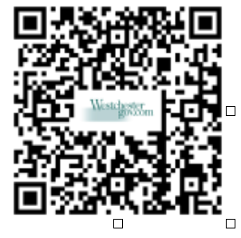
NAMI Westchester

Licensed Outpatient Substance Abuse TREATMENT Programs for Adolescents in Westchester

Central Park Recovery, (914) 619-5242
2176 Central Park Avenue, Yonkers NY, 10710
Nicole Intervallo, Director
Counseling Center at Yorktown Heights, (914) 962-5101 2000 Maple Hill, Yorktown, NY 10598
Dair Melendez-Drier, Director of Adolescent Program
Guidance Center of Westchester, Sunrise (914) 613-0700 x 7445
256 Washington Street, Mount Vernon NY,10550
Thurman Brown, Director
Innovative Health Systems, (914) 683-8050 20 Church Street, White Plains, NY, 10601 Jeanine Klotzkin, Director
Lexington Center for Recovery Mt Kisco Program (914) 666-6740
24 Smith Avenue, Mount Kisco, NY, 10549
James Hughes, Program Director
Lexington Center for Recovery New Rochelle Program
(914) 235-6633
3 Cottage Place, New Rochelle, NY, 10801
Carey Wardell, Director
Maxwell Institute, St Vincent’s Hospital, (914) 337-6033 A Division of Saint Joseph’s Medical Center
92 Yonkers Avenue, Tuckahoe, NY 10707
Karen Goldman-Hertz, Director
Mountainside Treatment Center, (914) 534-6030 480 North Bedford Road, Chappaqua, NY 10514 Jana Wu, Outpatient Program Manager
Thea Ross, Information (203) 219-2800
Peekskill Pathways/Sun River Healthcare (914) 734-8740
1037 Main Street, Peekskill, NY, 10566
Lorna Johnson, Director
Phelps Memorial Hospital (ATS), (914) 944-5220
22 Rockledge Avenue, Ossining, NY, 10562
Heather Howe, Director
St. John’s Riverside Hospital (Archway), (914) 668-1450 or (914) 668-1451
20 East First Street, Mount Vernon, NY, 10550
Elaine Bryant, Director
St. John’s Riverside Hospital (Greenburgh), (914) 683-5311
30 Manhattan Avenue, Greenburgh, NY, 10607
Kim O’Mara, Director
St. John’s Riverside Hospital (New Focus), (914) 964-8000
2 Park Avenue, Yonkers, NY, 10703
Sherlon Quarless, Director
St. Joseph’s/St. Vincent’s – Harrison, EXCEL Program
275 North Street, Harrison, NY, 10528
Rosie Martinez, Director, (914) 925-5112

Licensed Substance Abuse PREVENTION Programs for Adolescents in Westchester
Archdiocese Drug Abuse Prevention Program (ADAPP)
Administrative Office, (718) 904-1333
2789 Schurz Avenue, Bronx, NY 10465
Christine Cavallucci, Director

Cortlandt (Town of) Division of Recreation
(914) 736-0498
3 Memorial Drive, Croton, NY 10520
Administrative Office (914) 734-1050
1 Heady Street, Cortlandt Manor, NY 10566
Katherine Sclafani, Director

Harrison Youth Council (914) 835-7500
84 Calvert Street, Harrison, NY 10528
Amanda Ammirati, Director

Hastings Youth Advocate Program (914) 478-2471
44 Main Street, Hastings-on-Hudson, NY 10706
Joann Reed, Director

Larchmont/Mamaroneck Community Counseling Center
(914) 698-7549
234 Stanley Avenue, Mamaroneck, NY 10543
Mark Levy, Director

Student Assistance Services Corporation,
Administrative Office, (914) 332-1300
660 White Plains Road, Tarrytown, NY 10591
Ellen Morehouse, Director

White Plains Youth Bureau (914) 422-1378 11 Amherst Place, White Plains, NY 10601 Frank Williams, Jr. Executive Director
YCAP Yonkers Community Action Program
(914) 423-5905
164 Ashburton Avenue, Yonkers, NY 10701
Don Brown, Director

YMCA – Youth & Young Adults Club House
(914) 963-0183
17 Riverdale Avenue, Yonkers, NY 10701
Vincent Taliaferro, Director

Other Resources:

Helpful website: www.powertotheparent.org; www.ForDrugHelp.com
For programs out of Westchester: 1-877-8-HOPE NY [1-877-846-7369], Combatheroin.ny.gov
Cove Care Family Navigator Program: 1-845-225-2700 Ext. 245, Susan Salomone, Resource Manager
Compiled by Student Assistance Services Corporation
Last Updated on 6/15/22

Licensed* Programs providing ENCOMPASS Treatment** for Adolescents
with co-occurring Mental Health & Substance Use Disorders

Cognitive & Behavioral Consultants (Private Practice)
  - 1 North Broadway #704, White Plains, NY 10601
Jensyn Marquesano, Intake Coordinator, 914-385-1150, jmarquesano@cbc-psychology.com

Family Services of Westchester (OMH, IOS)
  - One Gateway Plaza, Suite 3B, Port Chester, NY 10573
Lupita Deluccia, Site Director, 914-305-6837, ldeluccia@fsw.org
  - 7-11 South Broadway, White Plains, NY 10606
Lindsay March, Site Director, 914-948-8004, x22, lmarch@fsw.org

Mental Health Association-Westchester (OMH)
  - White Plains Clinic: 300 Hamilton Avenue, Suite 201, White Plains, NY 10601
  - Yonkers Clinic: 200 South Broadway, Suite 402, Yonkers, NY 10701
  - Mt. Kisco Clinic: 340 Main St, Suite 301, Mt. Kisco, NY 10549
  - Nyack Clinic: 311 N. Midland Avenue, Suite 3
Rosemarie Spencer, Senior Director SUD Services, 914-610-5505, spencerr@mhawestchester.org

St. Vincent’s Hospital (OMH, OASAS)
  - 275 North St, Harrison, NY 10528
Lorena Rucaj, Outpatient Mental Health Services Coordinator, 914-925-5354, lrucaj@svwsjmc.org

The Guidance Center of Westchester (OMH, OASAS, IOS)
  - 256 Washington St, Mt Vernon, NY 10553
  - 150 Huguenot Street, New Rochelle, NY 10801
Carolyn Hatfield, Director Mt. Vernon Clinic, 914-613-0700 x7416, chatfield@theguidancecenter.org
Westchester Jewish Community Services (OMH, IOS)
  - Hartsdale Family Mental Health Center, 141 North Central Avenue, Hartsdale, NY 10530
  - Mount Vernon Family Mental Health Clinic, 11 West Prospect Avenue, 4th Fl, Mt. Vernon, NY 10550
  - Yonkers Family Mental Health Clinic, 487 South Broadway, Yonkers, NY 10705
William Mullane, Director of Innovation, Integration & Community Partnerships, 914-761-0600 x3211, wmullane@wjcs.com

Student Assistance Services Counseling Center
660 White Plains Road, Suite 100, Tarrytown, NY 10591 ~
Phone: (914) 874-1660 ~ Fax: (914) 524-0444

INPATIENT AND RESIDENTIAL ADOLESCENT FACILITIES

MENTAL HEALTH HOSPITALS

Four Winds Hospitals, 914-763-8151 x 2007
Must arrive by 10PM for evaluation (if bed available),
or appointment scheduled for the next day
800 Cross River Road, Katonah, NY 10536
Rosina Juman, Director of Admission,
direct #: 914-763-8151 x 2007

NY Presbyterian Hospital, 914-997-5700
Must arrive before 10PM for evaluation,( if bed available)
21 Bloomingdale Road, White Plains, NY 10605
Ruth Mendelowitz, Dir. of Access Svs, 914-997-5879

Westchester Medical Ctr, 914-493-7000 x 3
100 Woods Road - BHC B-210, Valhalla, NY 10595

St. Vincent's Hospital, 914-925-5320
Must arrive by 10 pm for evaluation, (if bed available)
275 North Street, Harrison, NY 10528,
Prevention & Response Team 914-925-5959

Hospitals withOUT AN Adolescent Unit
For after-hours psychiatric emergency evaluations, clients should go to the closest hospital. In the event hospitalization is needed, evaluating hospital will forward evaluation to those hospitals w/adolescent units

Northern Westchester Hospital, 914-666-1254
Emergency Department
400 East Main Street, Mount Kisco, NY 10549
Phelps Hospital, ER 914-366-3590
or Main Number 914-366-3000
701 North Broadway, Sleepy Hollow, NY 10591
St. Johns Riverside Hospital, 914-964-4444
Ask for Emergency Room
2 Park Avenue, Yonkers, NY 10703
Saint Joseph’s Hospital, 914-378-7622
Ask for Emergency Room
127 S. Broadway, Yonkers 10701
White Plains Hospital, 914-681-0600
Ask for Emergency Room
41 E Post Road, White Plains, NY 10601

SUBSTANCE USE Inpatient/Residential

Camelot Family Foundation, 718-981-8117 x411
- Intensive Male Residential
460 Brielle Avenue, Staten Island, NY 10309
- Young Adult Residential (MALE 19yr & up)
273 Heberton Ave., Staten Island, NY 10312
Intake Coordinator, Justin San George

Caron, 800-678-2332
243 N Galen Hall Rd, Wernersville PA, 19565
Admission Specialist, Megan

Dynamic Youth Community, Inc.,718-376-7923
DYC Fallsburg Residential Facility,
5803 Route 42 / PO Box 101, Fallsburg NY 12733,
M-F 9am-6pm
Intake Director, Marina
(Admissions handled through Brooklyn office)

Hope House Hubbard Center I, 518-486-8970
(Only Male 16-20 yrs.)
573 Livingston Avenue, Albany, NY 12206
Dir. Of Residential Services, Megan Duncan
Admissions Manager, Tony (518) 486-8973

Mountainside Canaan, 203-219-2800
187 South Canaan Road, Canaan, CT 06018
Referrals, Thea Diserio Ross,
Admissions Dept. 800-762-5433 x 1

Newport Academy, 844-669-8706 (from website)
36 Old Kings Highway S, Darien, CT 06820
Intake Coordinator, Kelly Kucinoki 973-713-5843

Never Alone Rehab, 845-339-4272
20 Crofts Road, Hurley, NY 12443
Clinical Program Director, Virginia

Outreach House II, 631-231-3232
400 Crooked Hill Rd, Brentwood, NY 11717
Intake Coordinator, Marissa

St Joseph’s Addiction Treatment, 800-776-7344
Rose Hill Residential
100 County Route 43 Box 100, Massena NY, 13662
Referral, Sharon Gushlaw

Student Assistance Services Community Resources

Al-Anon and Alateen
www.westchesterputnamalanon.org

Bereavement Center of Westchester
(914) 787-6158

Child Protective Services
24/7 NYS Central Register (SCR) Mandated Reporter Hotline: (800) 635-1522

Drug Enforcement Administration (DEA)
(646) 342-0190
Special Agent Pete Strauss, DEA NY
(571) 776-3496
Joannna Mlicka-Anderko, Senior Prevention Program Manager

Green Chimneys Arbor House Putnam Runaway and Homeless Shelter
(845) 279-2378
24/7 Hotline: (845) 279-2588

Hopes Door
(914) 747-0828
24/7 Confidential/Bilingual Helpline/Shelter:
(888) 438-8700
50 Broadway
Hawthorne, NY 10532
Maya Lloyd, MPH
Director of Outreach & Engagement
Kayla Stephens, MHS
Youth Educator & DV Counselor/Advocate

Mental Health Association (MHA)
General Information: (914) 345-0700
Suicide Crisis Hotline: (914) 347-6400
24/7 Family Abuse Services Hotline:
(914) 347-4558

Mid-Hudson Regional Addiction REsource Center (MH-RARC)
(845) 765-8301 Ext. 110
(914) 332-1300
Christine D’Annibale
https://Fordrughelp.com

My Sister’s Place
(914) 683-1333
24/7 Hotline (800) 298-7233 (SAFE)
3 Barker Ave
White Plains, NY 10601

National Alliance on Mental Illness (NAMI)
(914) 592-5458
9am- 2pm, Monday- Friday

New York State Center For School Safety (NYSCFSS)
(800) 330-1420 Ext. 205
41 State Street, Suite 403
Albany, NY 12207

NYS Office of Mental Health
NY Project Hope Emotional Support Helpline
(844) 863-9314
8am- 10pm/ 7 days

NYS Substance Abuse HOPEline
(877) 8-HOPENY or Text to 467369

One Love
For Workshops, Books and Resources, visit https://joinonelove.org/

Planned Parenthood
(914) 761-6566
White Plains Health Center
175 Tarrytown Road
White Plains, NY 10607

Poison Control
New York Regional Poison Control Center
(800) 222-1222
New York City Department of Health
& Mental Hygiene
455 First Avenue, Room 123
New York, NY 10016

Sanctuary Westchester Runaway and Homeless Youth Shelter
(914) 593-0667
24/7 Hotline: (888) 997-1583

Suicide Hotline
24/7 National Suicide Prevention Hotline
(800) 273-TALK
24/7 National Hope Line
(800) SUICIDE / (800)784-2433
24/7 Suicide Crisis Text line 988

Westchester County Department of Community Mental Health
Support and referral line:
(914) 995-1900 or send a Text to (914) 461-7281
(8am- 8pm, Monday through Friday)
24/7 Crisis Text Line: Text “Home” to 741741

Westchester County Opportunity Program (WestCOP)
Victims Assistance Services (914) 345-3113
24/7 Rape/Crisis/Trauma Emergency Helpline:
(914) 345-9111

Westchester County Police
(914) 865-7701
Sergeant Joaquim Brito, Drug Recognition Expert (DRE)

Westchester Crisis Prevention Response Team
(800) 925-5959

Westchester Jewish Community Services
(914) 761-0600
845 North Broadway
White Plains, NY 10603
Trager Lemp Center:
Treating Trauma & Promoting Resilience Sexual Abuse Treatment Program
(914) 949-7699
Center Lane (914) 423-0610

Other Resources:
Helpful Websites: www.powertotheparent.org
For programs out of Westchester: (877) 8-HOPENY/ (877) 846-7369 www.Combatheroin.ny.gov
Cove Care Family Navigator Program: (845) 225-2700 Ext. 245 Susan Salomone, Resource Manager

