50 Simple Acts of Self-Care
When we’re not operating at 100%, asking ourselves to do anything beyond the bare essentials can feel like too much. Usually, the only self-supporting things we can motivate ourselves to do, are those we know from experience, work. That’s why I’ve put together this list of simple techniques–a mix of evidence-based, and my own creations, that have consistently proven effective.
Whether you’re in need of calming, grounding or mood-boosting, you will find tons of techniques here to support you!
I encourage you try as many of them as you can, to learn what works best for you.

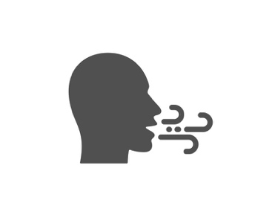

Slow Breaths
As soon as you open your eyes, take a 5 slow-second inhale through your nose, 4 slow-second exhale through your mouth 5x. If you’re stuffed up, mouth is fine for both. Try to hold thoughts at bay by focusing your attention on the sensations of the inhale and exhale–the air streaming in, the coolness or warmth, etc.

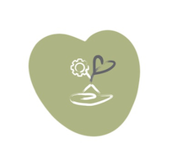

Morning message
Have your first thought of the day be an intentional and encouraging one. It can be something like: “I’m going make the most of this day” or “Today is another chance to feel better” or whatever else tells you that you have reason to be hopeful and proactive.

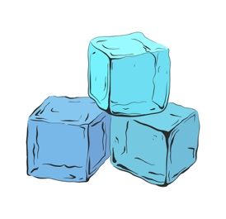

Cold water splash
Splash your face 5+ times with cold water to stimulate your Vagus nerve which will help to create a sense of calm. Learn more about why that’s a good thing HERE).

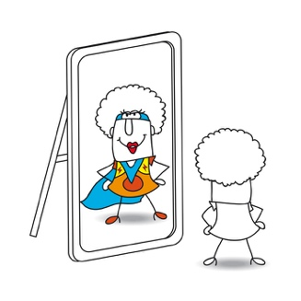

Be kind to your reflection!
When you see your reflection in the mirror first thing in the AM, if anything unkind comes to mind, nip it in the bud either by taking a deep breath, refocusing your attention on something else, or sending yourself a more assuring self-message (ie. "I am far more than a face or body").

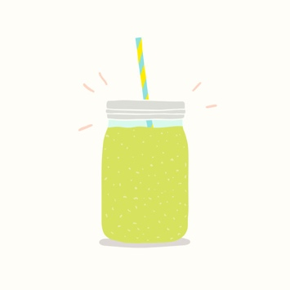

Green juice first thing
This can be store bought or made at home (ideally organic). The key ingredient here is celery which I’ve found does wonders for anxiety, and can also include other nutrient dense, alkalizing, hydrating, and digestion boosting veggies and spices like kale, cucumber, apples (for a little sweetness), ginger, garlic (though go easy on this if you have a sensitive stomach. And try to wait 20 minutes before eating anything. This will help to address any underlying nutrient deficiencies, dehydration, pH imbalances and/or digestive issues that might be contributing to your mental unwellness. For more on the gut-brain connection check out this Harvard Health article.
And if green juice isn't possible, then be sure to start your day off with a glass of water–warm and with lemon is best (here are a few reasons why).

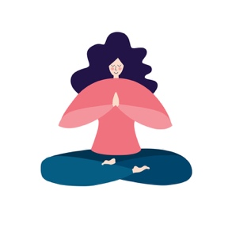

A little yoga (or stretching)
Sun Salutations are a series of fairly simple yoga poses that can help to expand the lungs, limber the spin, strengthen your arm and leg muscles while giving your whole body a great stretch. By combining movement and breath in this way, you get your blood pumping, and oxygen flowing to your brain which is both energizing and calming. Even two sun salutations can give you a sense of doing something good for yourself, helping to set a positive tone for the day. Check out this video to learn how to do them. And if you're not up for yoga, you can try these simple stretches from the comfort of your bed!

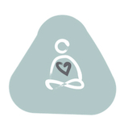

Pause & Breathe
The most effective (and always accessible) tool we have to regulate our nervous system and create a more relaxed state, is conscious breathing. When combined with physical touch, it can also help to ground us in our bodies. Use this technique whenever you feel yourself becoming anxious or your mood sinking:
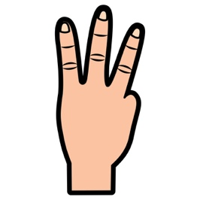
Finger breath
Press three fingers down gently on your arm (or leg) and extend them out while you take an inhale on a slow count of four, then on the exhale draw your fingers back–again on a slow count of four. For an added dose of calming, try holding your breath gently for a four count after the inhale, then add a hold after an exhale. You may find that silently counting helps to focus your attention on your breath, but it works just as well to approximate the ‘4-count’ by going as slowly as is comfortable.

Infinity Breath
This is another breathing technique you can do anytime. Start with your finger at the middle point of the symbol, and take a slow (3-4 second) breath in as you make the first circle, and a slow exhale as you trace the second circle–so your out-breath will start as soon as your finger reaches the middle point again.

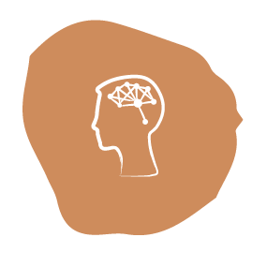

Tune-in to your thoughts
Our thoughts have a profound impact on our emotional state. While some are neutral (like making a mental grocery list), most are either creating or reinforcing a good (or not-so-good) feeling. Not surprisingly, the thoughts going through our heads when we’re depressed or anxious tend to be unhelpful at best; harmful at worst. So, whenever your mood takes a negative turn, try tuning-in to what’s going on in your head. Is what you’re saying to yourself or picturing, making you feel better or worse, calm or anxious, hopeful or despairing?
Read on for how to manage the less-than-optimal thoughts!

Erase with a breath
Whenever a negative thought arises, replace it with a breath. As you notice the words or images forming in your mind, imagine sending an inhale right into them and see/feel them dissipating as you do. You can also imagine your breath has a soothing color to it that fills your head with a healing energy. And if it comes back
(they can be persistent!) try to…

Add a word to your breath
A great way to take the charge out of (neutralize) negative self-talk/imagining, is to think of a calming word as you breathe. Choose a 2-syllable word with a calming resonance like “peaceful”, “easeful” or “soothing”, then inhale on the first syllable (i.e. “peace”) and exhale on the second (“ful”).

Appreciate what you can
Whenever you’re aware of something positive (a moment of calm, a kind word from a friend, a professional accomplishment, a nice meal, or a smile from a stranger), stay with the good feeling for a moment, trying to absorb its goodness, instead of just moving onto the next thought or action. And as you do, make a mental note of it with something like “This is good” or “I’m so glad about this.” Every time you actively appreciate something, you are–as famed psychologist and author Rick Hanson says: "turning good facts into good experiences", which act like nutritious food for your mind.

Eat like your mind depended on it
It’s important to get bloodwork done to determine if you have a nutrient deficiency and/or thyroid or other condition that might be impacting your mental health. You can download a list of recommended blood tests in this post. This will also help you create the most mood-boosting diet possible. In general though, you want to get adequate Vitamin D, B12, Zinc, Magnesium, Probiotics, Omega 3 Fatty acids, Probiotics, and–and this one is hugely important for those of us with anxiety–get plenty of H2O!

And limit sugar!
Too much sugar can increase inflammation in your gut (and throughout the body), and as the gut sends hormones, neurotransmitters, and immunological factors to your brain, gut inflammation can contribute to mood disorders, including anxiety and depression. Amongst the foods that help to lower blood sugar are: avocados, legumes, garlic, cold-water fish, oatmeal and oat bran, nuts, sweet potatoes and yams, whole wheat bread, yogurt, cinnamon, onions.
And those morning juices help too! Leafy greens like kale, chard, and spinach are high in fiber and Vitamin A and magnesium, which together work to lower blood sugar levels. In addition to their fiber and water content, celery and cucumbers are also anti-inflammatory. And don’t fear apples as they can reduce insulin resistance which leads to lower blood sugar.

Treat yourself like a true ally would
Imagine that you have been charged with the task of acting as your own greatest ally. Your job is to treat yourself as you would a dear friend or loved one, showing yourself unfailing compassion. This compassion expresses itself in many ways; through the kindly inner voice that acknowledges your pain and struggle; the patience you demonstrate when you’re having a hard time getting things done; the gentle reminder you offer yourself of your worth, your strength, and capability.

Create an anchor-thought
This one is extremely helpful when you feel yourself becoming despondent. The idea is to create a mental picture of yourself doing well in the near future, and stay with that image until you feel like you can really believe in it. As you start to get a felt-sense of the happier, healthier future-you, you can reinforce it by affirming “This is me”, “This is where I’m heading” or whatever self-message most resonates.
This image may be of you in a place or with people you love, doing your favorite activity, or simply looking and feeling well. I think of this as a kind of anchor-thought because it’s as though you’re on a boat a little way out to sea but connected by a powerful chain to this anchor of hope, and with every positive action you take, you are pulling yourself closer in to shore and safety. Then, whenever you feel yourself resisting a self-supporting action (exercising, socializing, eating well), you can use this anchor-thought as an incentivizing reminder of why you will choose to do it.

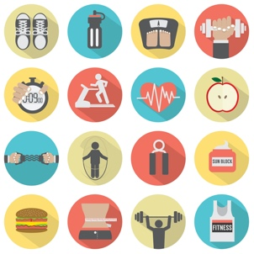

Get moving
It is damn hard to motivate ourselves to exercise when we’re in a compromised mental state but the positive impact makes it well worth giving ourselves a serious push. Even just 20 jumping jacks, taking a walk, a swim, a hike, some yoga, anything to get your body moving. Check out this post to learn more about why exercise is so important for our mental health and some helpful tips on how to work it into your daily routine.

Sunshine (or at least some fresh air)
Even if you don’t consider yourself a ‘nature-person’, being amidst trees, watching the ocean, strolling through a park, being in any natural environs can give you a sense of ease like nothing else. It’s essentially a place free of ‘triggers’ (assuming of course you're not venturing through snake infested terrain). And there’s a good bit of research supporting nature as a stress reliever, energy and memory booster, as well as anxiety reducer, so see if you can give yourself the gift of some ‘green-time’ at least once a week. And if nature’s not accessible, you can still get the benefits of fresh air, Vitamin D, sunlight, and exercise from a 20-minute walk anywhere!

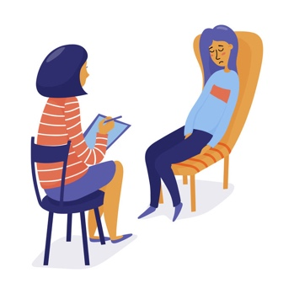

Therapeutic support
If therapy is an option, consider finding someone who has expertise in one or more of the following as these have been proven highly effective in addressing symptoms of depression and anxiety: Neurofeedback, EMDR, Hypnotherapy, EFT Tapping, CBT (Cognitive Behavioral Therapy) or DBT (Dialectical Behavioral Therapy).

Give yourself some good news
We’ve got bad news coming at us from every angle. Conflict, disaster, terrorism, scandal, and crises of every kind. Add that to an already challenging experience of depression and anxiety and you need to inject some positivity whenever possible! Check out these alternative news sources for a dose of good: Good News Network, YES Magazine, The Optimist Daily, Greater Good Magazine, and Positive News. And if you’d prefer your news the good old-fashioned way, check out The Happy Newspaper.

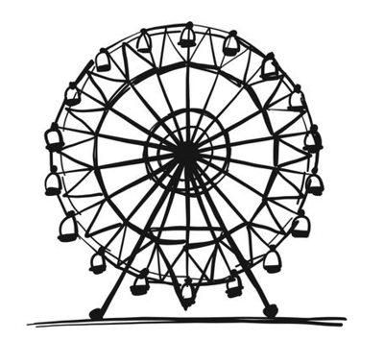

Do some kid stuff
Sometimes we just need a dose of kid-like fun. The kind that gets us out of our heads and into the moment. It can be a fair, an amusement park, an arcade, a water park, a kid’s movie, an indoor racetrack, sledding, getting an ice cream cone with colored sprinkles (hot chocolate with marshmallows works well too!) or even playing board games.

Take a moment to just be with life as it is
For a moment, try not to pull away from anything, fight anything, change anything, or figure anything out. To do that, notice the following one at a time and name it without judgment or commentary:
Something you see in front of you.
Something you can hear.
Anything you can smell (if no scent is immediately evident, you can simply notice the air going in and out of your nose).
Anything you can taste(if there’s no identifiable taste in your mouth, just notice the position of your tongue or if there’s saliva forming in your mouth).
Something can physically touch.
Any strong physical sensation in your body.
If you do find yourself judging—positively or negatively—simply take a breath and let it go. Check out this post for more on what I call “neutral noticing” and how to use it.

Calming activities
Reading a good book or listening to an audiobook can be supremely relaxing, or if you prefer TV, make it something humorous or otherwise uplifting (I love HGTV for getting my mind off a crappy day!)

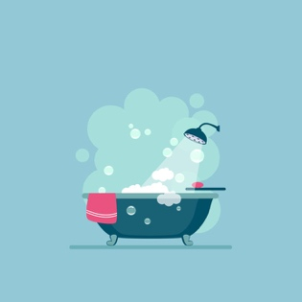

Take a hot bath or shower with essential oil
Lavender, rose, geranium, jasmine, sandalwood are all known for their sleep-promoting, stress-relieving, pain-reducing and mood-regulating benefits. Our sense of smell is directly wired to the brain’s centers of memory and emotion which is why a familiar smell can instantly trigger a flood of emotions.

No eating after 8!
Eating too much in the evenings and/or eating after 8pm can negatively impact sleep patterns. Beyond that, lying down immediately after eating can lead to indigestion, acid reflux and heartburn.

Have a Drowsy Drinkable
Herbal teas like chamomile and valerian are known to have relaxing properties while peppermint can be both soothing to the nervous system and stomach.
Tart cherry juice is high in melatonin, the primary hormone that regulates your body’s sleep-wake cycle and, most importantly, triggers sleep. Be sure to choose an organic, low sugar variety.
Warm milk contains tryptophan which naturally increases serotonin, a neurotransmitter known for creating a sense of well-being, and is a precursor to the aforementioned sleep-regulating hormone melatonin.
Golden almond milk combines almond milk, which is high in sleep-promoting hormones and minerals, including tryptophan, melatonin, and magnesium, with tumeric, which is rich in the compound curcumin, known to fight inflammation and promote relaxation.
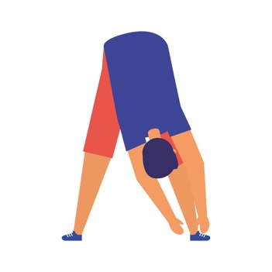

Some gentle stretching
Stretching helps to relieve muscle tension and prevent sleep-disrupting cramps, while also getting us out of our heads and focused on our bodies. Another great option is using a roller which I find works like magic to alleviate muscle tension. Check this out for some great, before-bed stretches and this for how to use a roller.

Try a weighted blanket
The gentle pressure applied by weighted blankets has much the same physiological effect as hugs and cuddles, increasing the release of serotonin, the chemical in the body that promotes relaxation. Studies have shown that weighted blankets can help to alleviate insomnia, lower anxiety, and lower blood pressure and pulse rate, and they just feel so comforting!

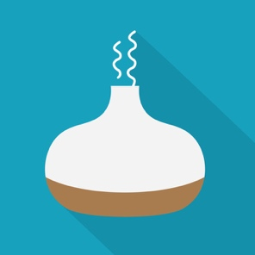

Use an essential oil diffuser
There’s of course much science to support the power of scent on our mood; beyond that though, is the simple, calming pleasure of beautiful smells.

Peaceful Sounds
White noise is like a sound-blanket that covers over other existing sounds (think whirring fan, wind in the trees, streams, waves); the consistent focused sound of white noise has a calming effect for many people. Pink and brown noise operate on the same premise but at lower frequencies (think thunder or a waterfall). Any of these can help you to fall and stay asleep, and you'll find many options when you search “sleep sounds” apps.

Recall the good
Before sleep, take a few minutes to run through your head and/or write down in a journal anything that felt good during the day—a pleasant conversation, a moment of calm, a smile from a passerby, anything kind you’ve done for yourself or others. Large or small, everything counts. As you recall these positive moments, try to hold your attention on them for a moment until you get a full sense of their benefit.

Sleeping breath
Doing this exercise before bed can combat nightmares and ensure a good night’s sleep. This is also a great breathing technique for whenever you’re experiencing symptoms of stress or dysregulation during the day. You can do this sitting or lying down.
Breathe slowly into your diaphragm on the count of four.
Hold for a count of seven, being sure to keep your body relaxed as you do.
Exhale for a count of eight.
Repeat a minimum of 10 times, fewer repetitions are significantly less impactful.
If you feel your jaw getting tight as you do this, you can soften it by stretching out your tongue as far as it can go, then keep your teeth separated when you close your mouth.
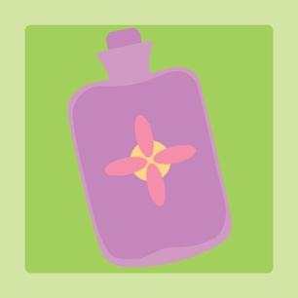
Heating pad and/or heated neck roll
Place a heating pad on your stomach and/or place a heated buckwheat neck pillow around your (you guessed it) your neck. The combination of pressure and warmth is very calming.
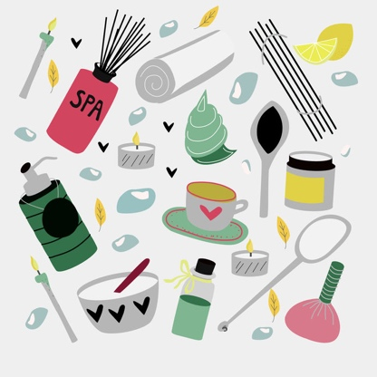

Get (or give yourself!) a Massage
fMRI studies show that massage triggers changes in regions of the brain involved in emotion
regulation and the stress response. It also works to decrease levels of cortisol and activate the
parasympathetic nervous system (the one that calms us). And if you've ever had a massage, you know that all that science translates into greater relaxation and a better mood.
If you’re able to get professional massage, awesome. For those of us limited by time or budget, a 20 min. foot or back rub at a local nail salon can hit the spot. And though it may not have quite the same relaxing quotient, self-massage, gives us most of the same benefits as the paid-for variety. Another stellar option (albeit one that often come with a hefty dose of “aayyyeee!!”), is using a foam roller. REI has some great suggestions on how to use one.
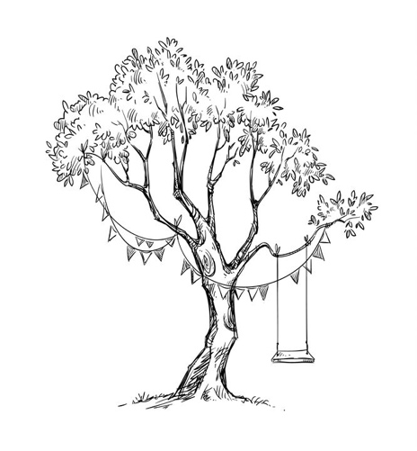

Take a Nature-Break
Even if you don’t consider yourself a ‘nature-person’, being amidst trees, watching the ocean, strolling through a park, being in any natural environs can give you a sense of ease like nothing else. It’s essentially a place free of ‘triggers’ (assuming of course you're not venturing through snake infested terrain!). And there’s a good bit of research supporting nature as a stress reliever, energy and memory booster, as well as anxiety reducer, so see if you can give yourself the gift of some ‘green-time’ at least once a week.
And if nature’s not accessible, you can still get the benefits of fresh air, Vitamin D, sunlight, and exercise from a 20-minute walk anywhere!

Tapping (aka. Emotional Freedom Technique)
EFT, more commonly known today as Tapping, is a simple technique that can be helpful in combating the dysregulation that results from emotional triggers. Originally conceived as Thought Field Therapy by Dr. Roger Callahan, EFT has evolved into a type of psychological acupressure which involves focusing on a specific issue while tapping with our fingers on the end points of energy meridians (aka acupressure points) situated just beneath the surface of the skin.
A ten-year study done at Harvard Medical School using fMRI technology showed that the stimulation of acupuncture points can reduce limbic system (our emotion and behavior regulator) arousal (Fang, 2009). The combination of sending kinetic energy through these points, while focusing on root causes, is said to assist in clearing out emotional blockages and lessening the intensity of (and in some cases even eliminating) the accompanying physical and psychological symptoms.
The idea is that you mentally recreate the trigger/trauma associated with your anxiety, which puts your amygdala in threat-response mode, and the ‘tapping’ sends signals through those acupressure points to shift you out of threat mode. So, while you still feel the emotion, your body is no longer affected by it in the same way.
While not a panacea, many people find that when used consistently, it does indeed contribute to a better quality of mental and emotional health. I find that Tapping can be especially helpful when combined with deep breathing and other regulating techniques.
Check it Out: You can get more details on EFT on Gary Craig’s website and find some excellent videos to guide you through more complex tapping sequences for myriad mental health challenges with EFT expert Brad Yates HERE. EFT can also be done with a therapist–you can find a list of EFT trained therapists HERE and HERE.

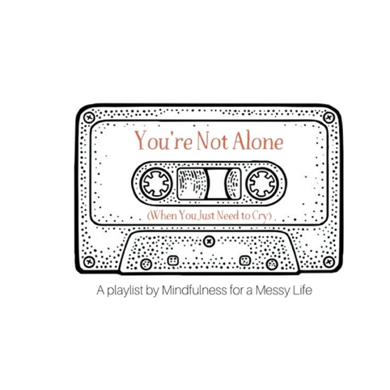

Get Musical
For many, music is a powerful force for healing. It can resonate on the level of our pain, reminding us that we’re alone. It can make us feel heard and known in a way that nothing else can. It can draw us deep into our pain, pierce through and soften it. We can feel a million miles away from any recognizable emotion and then hear a song that pulls us right back through all those miles of distance, into our bodies, into the heart of something powerfully real and present.
I've created three (ever growing) playlists for different moods/emotional needs, that you can access here. The first is the ‘You're Not Alone’ playlist which is comprised of songs that resonate deeply for me when I’m supremely down. Whether the lyrics, the sound, or a combination of the two, these songs intensify the hurt in that cathartic kind of way that leaves you feeling a little lighter and a little less alone, afterwards.
If you're looking for a mood boost, the Some Good Cheer playlist offers many genres of cheerifying, and if you really just need to hear something that will get you out of your head, the Get out of your head (and into your body) playlist should help to get you grooving!
Of course music is super personal and everyone responds differently to different sounds. Think about the music that has really impacted you, whether by giving you a sense of connectedness, aliveness, or calm, and consider making a mental wellness playlist for yourself.

Humor… it’s no joke!
You may be thinking, “humor, seriously?” Yes. Though laughter is likely the last thing on your mind when you’re deep in the mire, this healing technique actually has a good bit of science to back it up. Even at my worst points, there was always something about Eddie Murphy’s old stand-up routines that just reached right threw all the layers of misery to a spot in me that still felt alive. And in more recent years The Secret Life of Pets–I literally can’t not laugh at this movie!
In his article The Healing Power of Humor, Maud Purcell relates how Norman Cousins cured himself of a debilitating disease through the use of humor by watching old Marx Brothers movies and laughing uncontrollably. And indeed, he went on to live a long and healthy life. “Today we have a better understanding of how laughter affects human physiology”. It reduces pain, strengthens immune function, decreases stress, helps put life’s stressors into perspective, helps us to overcome fear, “encourages us to take ourselves less seriously, and triggers creativity.”
Here are some ideas on how to add a little levity to your life:
Get the funny up: Find some funny cartoons, photos or greeting cards–anything that elicits a chuckle–and hang them up at home or in your office.
Keep a funny file: Start a collection of your favorite comedies, standup routines (for some ideas, check out Rolling Stone online for their top 50 stand-up comedians of all time), and funny books (David Sedaris anyone?).
Make it ridiculous. When you find yourself in a nerve-wracking situation (such as locking your keys in the car) or ruminating on an unpleasant exchange, imagine that you’re a comedian charged with the task of rewriting the scene by blowing it up to absurd proportions.
For instance, if you’re picturing a fight you had with your significant other, imagine exaggerating their body language, facial expressions, and tone of voice, and amplifying every aspect of the exchange until it becomes full on ridiculous. Making the scene laughable helps to take the emotional charge out of it and give you some perspective. It may feel a little forced at first but trust you get a laugh out of yourself!
Hang with the laughers. When your life feels like the humor’s been drained out of it, spending time with those who appreciate a good laugh can prove supremely healing. And if you’re lacking that particular kind of compatriot at the moment, a comedy club can also do wonders for refocusing you on the funny.
Try laughter yoga. Yes, this is really a thing! According to Debbie Friend of DoYouYoga, laughter yoga “combines simulated laughter exercises with gentle breathing techniques to teach the body how to laugh without relying on jokes or humor.” Check out five laugher yoga exercises right here.
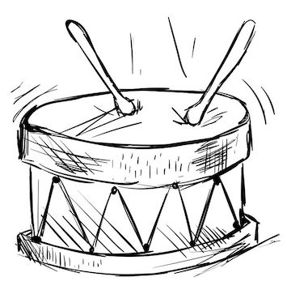

Meditative Drumming
In Psychology Today, sound therapist Gary Diggins is quoted as saying: “We moderns are the last people on the planet to uncover what older cultures have known for thousands of years: The act of drumming contains a therapeutic potential to relax the tense, energize the tired, and soothe the emotionally wounded.”
Yes, the simple act of pounding on a drum can release pent up anger and get us out of our heads and into our bodies. If this sounds like something you’d be open to, do a Google search on local drum circles or you can purchase a small hand drum and Youtube “basic hand-drum beats” to get you started.

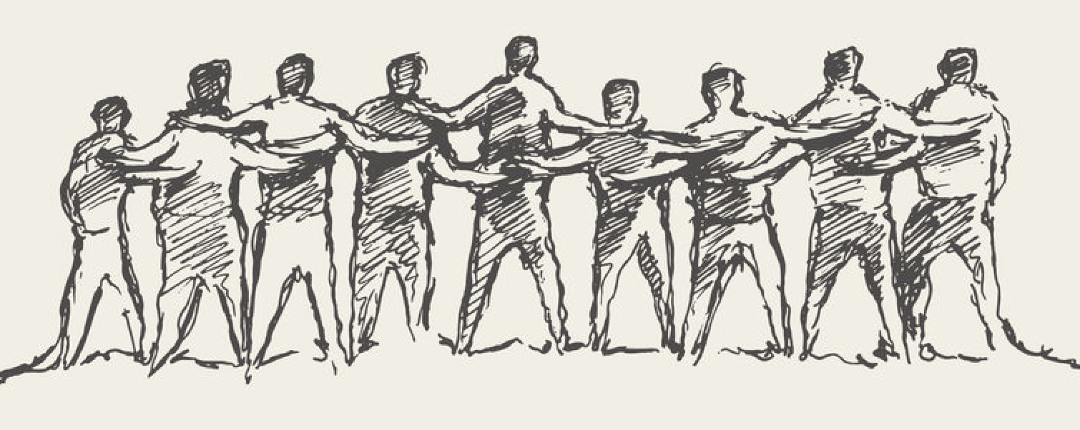

Acts of Kindness
Acts of kindness affirm the good in the world—the good that you can generate even with the smallest effort. Something as simple as making someone smile is enough, reaching out to someone in need, buying someone a cup of coffee, feeding someone’s parking meter, anything concrete. Acts of kindness don’t just pay it forward in the lives of others, they also have long term impact for you.
Science supports the supposition that doing something kind for someone else boosts our happiness levels by increasing the production of dopamine and oxytocin–two of the "feel-good" hormones. That’s one reason why volunteering has proven so helpful as part of a treatment plan for depression.
Serving others in any way is tangible proof that we are capable and have something valuable to offer. And there is ample evidence that volunteering reduces stress, combats depression, prevents feelings of isolation, increases confidence, gives us a sense of meaning and purpose–and increases our capacity for happiness.
So, whether you build into your life, an ongoing ‘organized’ act of kindness, or opt for the more spontaneous variety, challenge yourself to do something daily that you think will make a positive difference in a life or in the world (however large or small). You won’t regret it!

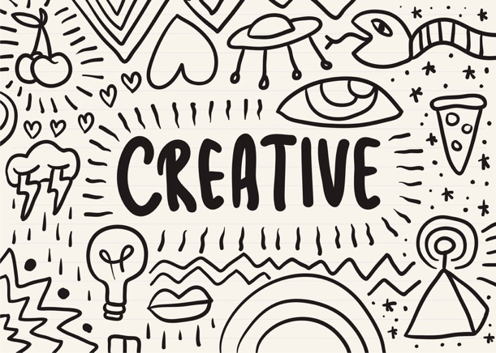

Get Creative
Channeling our suffering into creative expression can be hugely healing. It helps us process our emotional experience, move pent up negative energy out of our heads and bodies and into the world in a productive way, and make meaning where we can’t make sense. And if we choose to share the fruits of our creative efforts, it can also be a way of connecting with other people–both those struggling in similar ways, and those wanting to better understand what we’re going through.
Think about any creative activities you’ve enjoyed in the past, whether visual arts (drawing/painting/graphics), music, poetry, dance, prose, spoken word, performance art, textiles (sewing/knitting). Choose one to focus on right now and give yourself the gift of time to embark on a creative project. Of course, giving voice to our psychological pain is cathartic whether or not we choose to share it.

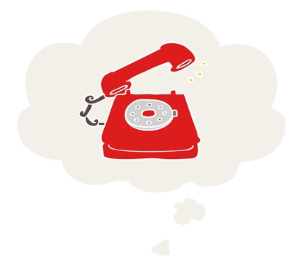
There are so many reasons we don’t reach out when we most need support. When we’re in the depths of despair or overwhelmed by anxiety, it’s hard to imagine anyone really understanding what we’re going through let alone being able (or willing) to help. We may be afraid of appearing weak or out of control, or fear scaring people off.
The truth is, our mental health challenges may create discomfort or confusion for some of the people in our lives. Keeping our struggle to ourselves though will only leave us feeling more alone and despairing. Admitting we need help–whether a listening ear or something more involved–is the first crucial step in helping ourselves through a tough time.
If you’re in need of support, consider who might be receptive to a request and reach out. If you're unsure of what to say, read over this list and see if any of these suggestions resonate.
“I’m not exactly sure what to ask for, but I’m feeling really (depressed/anxious/afraid) right now and don’t want to be alone. Can we meet up?”
“Things have been really hard for me lately– emotionally/psychologically–and I could
really use a friend, even just to do something fun and distracting.”
“I’m having a hard time now and would be so grateful if you’d check in on me (daily/ weekly/occasionally) to make sure I’m okay.”
"Things have been rough for me lately. I could really use a little boost. If there’s a nice memory you have of me, or just something about me you like or appreciate, would you share it with me?"
“I’ve been struggling a lot lately with my mental health and could really use your help in figuring out some things I can do to feel better.”
“I could really use a friend right now.”

For the Really Rough Days
There are always going to be days when things are super rough–whether or not you’re dealing with depression or anxiety. I recently had such a day (well, a few actually); a perfect storm of petrifying prospects and unfortunate happenings, and my only goal was to refrain from spending the day in a heaping puddle of tears. Here’s what I do on days like this:
Keep it Simple. Do the bare minimum and think about as little as you can. This is not the time to problem solve or to attempt to make meaningful progress on the personal or professional front. If there is something pressing that can’t wait, try to approach it in as logical a way as possible, breaking the task down into bite size pieces you can tackle one at a time. And remind yourself that you will get to everything as soon as you’re able (and mean it!)
Spend some time in fantasy-land. Ongoing mental unwellness is exhausting. Sometimes we just need a break, which is why I recommend a mental vacation to fantasy-land. Whatever your idea of paradise–picture it, in detail, and hang out there for a good long while.
Dialogue with your emotions. If I feel a surge of panic, I talk to it, maybe asking “what is this about?”; if I’m descending into a dark place I may ask myself “what do you need?” Approach the feeling gently, compassionately and with curiosity. I find that these kinds of questions draw out helpful information–the kind that would not likely just appear, especially when I’m in a bad state.
Remind yourself that whatever state you’re in right now, it’s not permanent. Nothing is. That is a fact. Try to recall other times in your life when you felt like the suffering would never end, then it did. And remind yourself “You’re okay, you’ve been here before and you’ve come out of it. You will get to the other side.”

